**VOICE-CONTROLLED SIGNAL LIGHTS VEST FOR**

**CYCLISTS FOR ENHANCED SAFETY AND**

**COMMUNICATION ON THE ROAD**

Arjay T. Añoso

Arjay S. Beligañio

John Rafael H. Brigildo

Southern Luzon State University

College of Engineering

**TABLE OF CONTENTS**

Chapter I Introduction

Background of the Study 2

Objectives 3

Significance of the Study 3

Scopes and Limitation 4

Definition of Terms 5

Chapter II Review of Related Literature and Studies

Related Literature 10

Related Studies 13

Conceptual Framework 16

Hypothesis 17

Synthesis 17

Chapter III Methodology

Research Locale 20

Respondents of the Study 20

Research Design 21

Research Instrument 21

Procedures 22

**Chapter 1**

**INTRODUCTION**

Bicycles are recognized vehicles under the law, they share the road with other vehicles, just like motorists. Cyclists have the same rights and responsibilities as drivers when it comes to traffic laws and guidelines. Nowadays, many individuals use it for recreational activities and also for modes of transportation.

Bicycle use in the Philippines has been on the rise in recent years, with a 2023 poll by the Social Weather Stations (SWS) finding that 36% of households in the whole country now had at least one person who cycles. This indicates a significant increase from the 29% of families that reported riding bicycles in 2022. On the other hand, cyclists must be aware that riding on a bicycle might provide risks in their lives. According to the 2021 MMDA’s report on bicycle-related road crash data in Metro Manila, 2,397 cyclists were involved in an accident, 33 of which were fatal. Therefore, the data emphasizes the importance of visibility of the cyclist on the road.

Cycling has various health and environmental benefits, however, there are major issues of concern for cyclists, one is lack of visibility particularly in low-light situations and weather conditions. Being visible on the road is essential for cyclists because it avoids incidents for cyclists and enhances communication with other road users. Another one is using hand signals that are more vulnerable to incidents.

Providing a means for proper visibility and safety for cyclists can make the road a better place for all road users. With this in mind, the researchers decided to develop a voice-controlled signal light vest for cyclists to enhance the safety and communication on the road.

**Background of the Study**

When it comes to cyclists along the road, being visible to other road users is crucial. In low-light settings such as dusk, dawn, or nighttime, bicycles are at a greater danger of not being readily recognized by automobiles. This loss of visibility leads to unsafe conditions, increasing the chance of accidents. Similarly, during inclement weather, such as heavy rain and fog, visibility may be greatly hindered, making it much more problematic for both bikers and automobiles to notice each other on the road.

In order to improve cyclist visibility on the road, using suitable lighting and reflective clothing is a critical step, as it increases the visibility of bikers, particularly in low-light settings. However, it's important to recognize that depending just on reflective gear will not be enough to avoid accidents, especially when bicycles are making turns. In such instances, additional safety precautions such as hand signals, this is also more likely to cause accidents due to leaving the hand to the handlebar. We can't be assured that making use of bright clothing and hand signals would lower the danger of traffic accidents for cyclists.

The developers came up with an innovative way to address the problem by developing a signal light vest for cyclists using voice commands. This vest will feature a MEMS microphone and a signal light system, enhanced with machine learning capabilities to recognize the user's voice commands. It stands out as an instance of innovation in the area of road safety. Cyclists, who are typically vulnerable in congested areas, benefit immensely from new technologies that improve their visibility and communication with other road users. This device, intended to be a useful addition to a cyclist's equipment, provides an innovative approach to solving safety concerns while promoting a sense of security and confidence on two wheels. This article delves into the development process of this revolutionary cycling accessory, shedding light on the path to safer and more connected cycling experiences. The objective is to address the problem of low visibility during cycling and improve communication with other road users. Not only will this approach satisfy the current problem, but it also brings up new possibilities for future researchers to look at more developments. The possibility for adjustments and discoveries in this subject is endless, and this study can serve as a basis for more thorough research in the future.

**Objectives of the Study**

To develop a signal lights vest that uses voice commands to address the problem of low visibility, lack of communication, and the use of hand signals while cycling. Specifically, the study aims to:

1. To design a signal light vest considering the materials, plan, and ergonomic design of the system.

2. To create a circuit for the signal lights vest that responds to the voice commands of the user.

3. To develop a program that performs the signal lights system depending on the cyclist's voice command.

4. To evaluate the efficiency of the voice-controlled signal lights vest.

**Significance of the Study**

The typical method of using lighting and reflective gear to be seen on the road and using the proper hand signal. However, this is not enough to minimize the risk of accidents due to various causes including low light, lack of communication and weather conditions, and poor safety of hand signals. Therefore, the findings from this study would be beneficial to cyclists, other road users, developers, and future developers.

For cyclists, the system will assist them to be properly visible on the road by generating a signal light using voice recognition commands.

For other road users, the system will allow them to see and anticipate bicycle movements, reducing the risk of accidents.

For future developers, this study may be applied as a reference for the development of further research and study.

**Scopes and Limitations**

The study focused on developing a working prototype that is able to generate a signal light system using a voice command based on the user and the device can be detachable to its specially made design vest so that the vest will be washable. This phase pertains to the creation of the design of hardware and software components of the device using sensors, LED’s, microcontrollers, and connectivity features to evaluate the usability of the system.  
 The system will limit only three types of signal lights, such as turn signal lights, brake lights, slowing downlights, and have an off-feature command to turn off the signal light display. Also, the study will not extend to the advanced factors identifying any other types of voice commands/words from the user.

**Definition of Terms**

For a better understanding and interpretation of this study, the following terms are operationally defined:

**Bicycle -** is a vehicle composed of two wheels held in a frame one behind the other, [propelled](https://www.google.com/search?sca_esv=571184275&q=propelled&si=ALGXSlbSiMNWMsv5Y0U_0sBS8EWzqzyxuXeyg6EGbMFGFtnbJ_xM83LAABtv_3fB9wNmOJ0oDzjnsX-5aDA4MrDLo6CqKOMfDQ%3D%3D&expnd=1) by pedals, and [steered](https://www.google.com/search?sca_esv=571184275&q=steered&si=ALGXSlYwkgxr-HbbJwcOTTqB6eth26fyfiR6ytSZSuArLJX0890lVI71wLnF-Q4yXwPfSaSr4UviF4qJX0fyENny0P14NnD-WA%3D%3D&expnd=1) with [handlebars](https://www.google.com/search?sca_esv=571184275&q=handlebars&si=ALGXSlbxwhdHKc0fpoiOcM6OGd45I5u061wog6Ris4HRGeAHBevIqyZjfKNcXa9R43gs7H2UMi-B_npRXT3L2RyO48Tu9Rnc0Q%3D%3D&expnd=1) attached to the front wheel.

**Cyclist** - refers to those who ride bicycles, whether for recreational or modes of transportation.

**LED matrix or LED display -** is a large, low-resolution form of dot-matrix display, useful both for industrial and commercial information displays as well as for hobbyist human-machine interfaces. It consists of a 2-D diode matrix with their cathodes joined in rows and their anodes joined in columns (or vice versa).

**Machine Learning** - is defined as a discipline of artificial intelligence (AI) that provides machines the ability to automatically learn from data and past experiences to identify patterns and make predictions with minimal human intervention.

**MEMS Microphones** - are a type of microphone that utilizes a tiny MEMS sensor to convert sound waves into electrical signals. These microphones are known for their small size, low power consumption, and high-quality audio capture.

**Microcontroller -** is a small computing device on a single integrated circuit used to control the operation of the Signal Light Vest, regulating lighting patterns and user interactions.  
**Signal Light Vest -** refers to a specialized wearable garment equipped with integrated lighting components such as LEDs, fiber optics, or electroluminescent panels designed to enhance the visibility and safety of the wearer, often a cyclist.

**Voice Command -** is a method of interaction where the user provides verbal instructions or commands to control and operate the functions of the Signal Light Vest. This can include actions like turning lights on or off, changing lighting patterns, or activating safety alerts using spoken words.

**Chapter II**

**REVIEW OF RELATED LITERATURE AND RELATED STUDIES**

This chapter reviews the related literature and studies of different published books and research, as well as internet sources, to provide a comprehensive understanding of this study. Furthermore, the gathered information will serve as the basis for the conceptual framework.

The literature review is an essential component of any research study. It allows researchers to develop a deep understanding of the topic of interest, to identify gaps in the literature, and to situate their study within the broader context of existing knowledge. By conducting a thorough literature review, researchers can ensure that their study is well-informed and that it makes a significant contribution to the field. (Martell, 2019, p. 1).

The review of related literature and study serves several important purposes. First, it helps the researcher to develop a deep understanding of the research topic. Second, it helps the researcher to identify any gaps in the existing knowledge that their study can address. Third, it helps the researcher to develop a theoretical framework for their study. Fourth, it helps the researcher to position their study within the broader context of the field. This means that the researcher should not simply summarize the existing literature, but should also evaluate its strengths and weaknesses. The researcher should identify any areas where the existing literature is incomplete, contradictory, or outdated. The researcher should also identify any opportunities to extend or refine the existing knowledge. (Creswell, 2018).

**ESP32-S3-DevKitC-1**

The ESP32-S3-DevKitC-1 is an entry-level development board equipped with ESP32-S3-WROOM-1, ESP32-S3-WROOM-1U, or ESP32-S3-WROOM-2, a general-purpose Wi-Fi + Bluetooth® Low Energy MCU module that integrates complete Wi-Fi and Bluetooth Low Energy functions.

Most of the I/O pins on the module are broken out to the pin headers on both sides of this board for easy interfacing. Developers can either connect peripherals with jumper wires or mount ESP32-S3-DevKitC-1 on a breadboard.

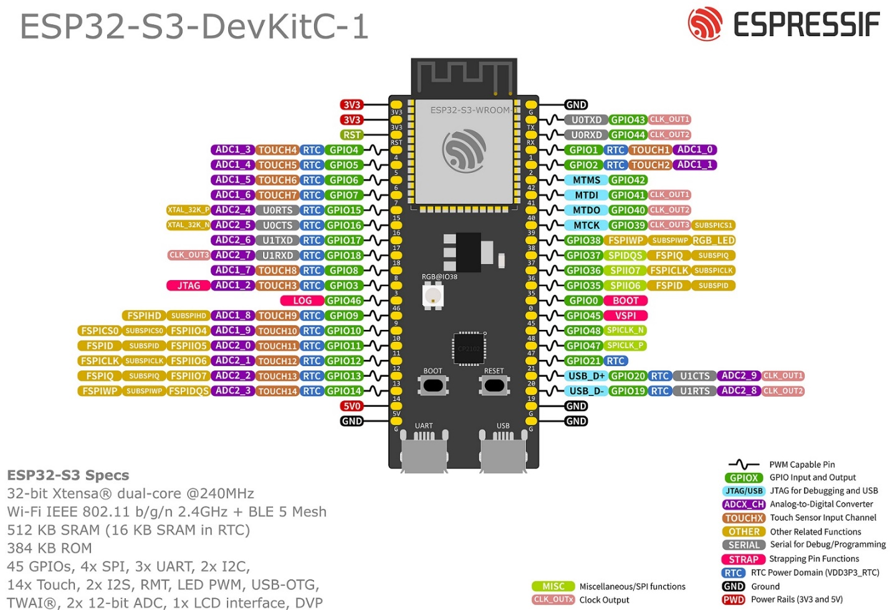

Fig. 1 ESP32-S3-DevKitC-1 pinout

**INMP441 MEMS Microphone**

The INMP441 is a high-performance, low power, digital-output, omnidirectional MEMS microphone with a bottom port. The complete INMP441 solution consists of a MEMS sensor, signal conditioning, an analog-to-digital converter, anti-aliasing filters, power management, and an industry-standard 24-bit I²S interface. The I²S interface allows the INMP441 to connect directly to digital processors, such as DSPs and microcontrollers, without the need for an audio codec in the system. The INMP441 has a high SNR, making it an excellent choice for near field applications. The INMP441 has a flat wideband frequency response, resulting in natural sound with high intelligibility.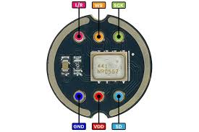

Fig. 2 INMP441 MEMS Microphone

**LED Matrix**

An LED matrix is a display device that is made up of a grid of light-emitting diodes (LEDs). These LEDs are arranged in rows and columns, forming a matrix structure. Each LED can be individually controlled to emit light, allowing the matrix to display patterns, text, or images.

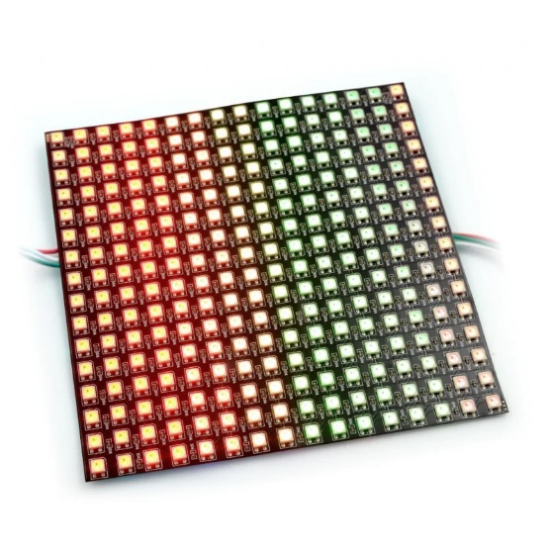

Fig.3 LED Matrix

**Cyclist Vest**

A cyclist vest is a versatile and practical piece of cycling clothing that can help cyclists to stay warm and comfortable in cool or windy weather. It is typically made of a breathable fabric with a fitted design, and can be worn over a variety of other cycling clothing. Cyclist vests are also often available in reflective or fluorescent colors to help cyclists be seen by motorists in low-light conditions.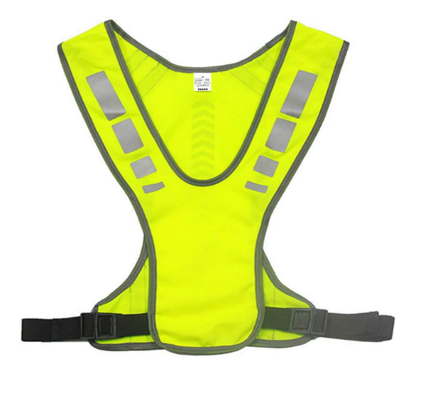

Fig.4 Cyclist Vest

**RELATED LITERATURE**

***VeloCity: Using Voice Assistants for Cyclist to Provide Traffic Reports***

G. Salvino et al. (2021) design, development, and evaluation of VeloCity, an application for reporting traffic incidents and structures relevant to cyclists. The authors compared three input methods (touch, in-app speech recognition, and the voice assistant of the operating system) and found that participants preferred to use the voice assistant as it was the least distracting. They also found that participants preferred short commands over conversational phrases. Based on their results, the authors presented five guidelines for designing voice user interfaces for cyclists.

Rangan et al. (2018), titled "Voice Controlled Smart Helmet," presents a comprehensive exploration of integrating voice control technology into motorcycle helmets. The system consists of a voice module to control the visor, turn indication, headlights, horn, and also the ignition system, the user is given much more options to control the vehicle rather than getting deviated from driving. Since the user uses voice controls to do the activities, he/she will stay awake throughout the ride.

Nordmark Anton (2019), stated that traffic is a complex environment in which many actors take part; several new technologies bring promises of reducing this complexity. However, cyclists—a particularly vulnerable road user group—have so far been somewhat put aside in these new developments, among them being *Cooperative Intelligent Traffic Systems* (C-ITS) and their aspects of human–computer interaction. This master’s thesis of industrial design engineering presents five multimodal collision warning signals for cyclists—future ones in these supposed C-ITS—using a novel application of bone conduction headphones (BCH) via sensations of both sound and touch. The thesis project was conducted as a complementary subset of the larger research project ‘V2Cyclist’ orchestrated by RISE Interactive. V2Cyclist set out to adapt the wireless V2X-protocol for cyclists by developing a physical prototype in the form of a bicycle helmet and a corresponding human–computer interface.

***LifeLight: Wearable Active Hazard Detection System for Urban/Suburban Nighttime Cyclists***

N. Hinson et al. (2019) use Arduino microcontrollers, which, in conjunction with HC-05 Bluetooth modules, facilitate the communication necessary for the system's operation. The HC-05 modules were configured in a master-slave setup, allowing one module to transmit signals while the other received them. One Arduino was equipped with a LiDAR and a logic converter. The TF-mini LiDAR sensor has a range of 12 meters in ideal conditions, but in reality, it works well up to 10 meters in the dusk and nighttime lighting conditions with less than 1% error. The LiDAR sensor works best when it is aimed at a surface that is at an angle of 60 degrees or less. To avoid detecting vehicles that are not a danger to the rider, the LiDAR is set to only detect vehicles that are directly behind the rider. The LiDAR has a very narrow beam, so it will not detect oncoming vehicles unless they are on a collision course with the rider. This system is to decrease the possibility of collision and visibility for cyclists and alerting them to vehicles approaching from behind.

***LED Bike Safety Vest***

FAHMIDDIN, A. W. Z. B. (2023) This study is intended to develop a safety vest for bikes using a gyroscope system. Wearable device that is designed to improve the visibility and safety of cyclists. The vest is equipped with a variety of LED lights that can be programmed to flash in different patterns, making the cyclist more visible to other road users. The LED in the vest automatically lights up depending on what the gyroscope system indicates, if you turn right the LED indicator shows your turning right and vice versa.

Maroma A. (2018) Development of Motorcycle Jacket with Modified Indicator and Brake Lights. The study dealt with the development of a motorcycle indicator and brake light system that is integrated into a standard riders jacket. The device was conceived for the purpose of increasing the visibility of the rider especially during night time. The system was developed in such a way that minimal modifications can be made to the lighting system of standard motorcycles in order to incorporate the device. The device was also fabricated by using materials that are readily available in the mainstream electronics market for ease of maintenance.

Fadzil, A., Jalaludin, N. A., & Sadun, A. S. (2022) suggested the blindspot detection system. The system uses ultrasonic sensors to detect nearby obstacles in the cyclist's blind spot area. When an obstacle is detected within 10 meters, the system alerts the cyclist with an LED light. When an obstacle is detected within 2 meters, the system alerts the cyclist with a buzzer. This gives the cyclist more time to avoid a collision.

**RELATED STUDY**

Cycling may be a great way to get exercise and take in the environment, whether you're commuting to work or just having fun around the community. Riding on the road, however, is risky as you never know whether cyclists or pedestrians will be paying attention to your turn.

According to Dulo, J. et al (2022), the signal light would consist of an automatic voice turn and a manual switch that could be mounted on your bicycle. The system’s design is focused on using voice recognition technology to activate signal lights on a vest worn by the cyclist, allowing them to make turns without having to raise their hands. The system is designed by using an Elechouse V3 module to train their voice recognition AI and created an AI with a Google Text-to-Speech library. They also used an Arduino Pro Mini/UNO. The collected data sets to assess whether or not the signal lights will turn on after the voice has been recognized. They concluded that a voice-activated signal light system for bicycles is a feasible and effective solution for improving cyclist safety on the road. They found that the system was able to accurately recognize voice commands and activate the signal lights in most cases. They also found that the system was easy to use and control, and that it could be a valuable tool for reducing the risk of accidents involving cyclists. However, they also noted that there were some limitations to the system, such as the need for clear and consistent voice commands and the potential for interference from background noise.

Voice-based direction indicator for the cycle was proposed by IJSHRE, (2022). A wearable device that is linked to an app, and a wireless control that eliminates the need to take your hands off the handlebar . The wearable device is a foam panel that snaps together and contains up to four LED signals: left, right, forward, and stop, to keep pedestrians informed at all times . The app is called Dabble and is designed to be easy to use . The purpose of the system is to assist bicycle riders in indicating their direction, as well as providing automatic headlight and horn . The wearable device is designed to keep pedestrians informed at all times, and the wireless control eliminates the need to take your hands off the handlebar. According to the study, they found that their solution is helpful for bike riders, but it still needs improvement in some parts . They tested the project on a bicycle and found that it provides automation, and the rider does not have to care about unnecessary things which can be automated . However, they also found that the horn automation part was a little annoying as it honks without the consent and sometimes it honks unnecessarily in traffic.

Smart LED Bike Jacket proposed by Alsalman et al. (2021), the study is about the development and evaluation of a Smart LED Bike Jacket (S.L.B.J). The purpose of the study is to implement a wearable jacket for cyclists that has different LED colors used for turning signals, provides physical alarms through vibration signals when objects are detected near the cyclist, and includes features such as night vision, a display screen, and a portable power bank charging mechanism. The study aims to enhance cyclist safety on the road and reduce the risk of accidents. They also found that the system was easy to use and control, and that it could be a valuable tool for reducing the risk of accidents involving cyclists. However, they also noted that there were some limitations to the system, such as the need for longer life span of the power source for the reason of some high power consumption of LEDs they used in the system.

According to Harshith H., Dr. M L Anitha (2020), highlighting the potential of development and implementation of the Smart Cyclist Jacket to address the challenges faced by cyclists in urban environments. The jacket's innovative design, coupled with the integration of technology such as LED indicators and voice command functionality, aims to improve the cycling experience and reduce the risk of traffic accidents. The Smart Cyclist Jacket, features LED indicators for left, right, and stop signals, which can be controlled through voice commands via the accompanying Android application. The purpose of these features is to enhance the visibility and safety of cyclists, particularly during night time, by providing a hands-free method of signaling and navigation. They found the potential benefits of implementing the Smart Cyclist Jacket, including the reduction of traffic accidents in major cities and the promotion of cycling as a mode of transportation. The authors suggest that the jacket's innovative design and safety features may attract more people to cycling and improve overall safety for cyclists. Also, they found highlights the potential for regulations mandating the use of safety gear for cyclists, similar to the rules for motorbike and car users.

**Conceptual Framework**

This illustrates the conceptual framework that will guide the researchers on their study. It is divided into three sections.

|  |
| --- |
| **PROCESS** |
| A. Planning  B. Designing  C. Selection of materials to be used in the study.  D. Circuit Construction  E. Programming  F. Assembling  G. Testing and evaluation of the whole system. |

|  |
| --- |
| **OUTPUT** |
| A detailed documentation of the Signal Lights Vest for Cyclist using Voice Command. |

|  |
| --- |
| **INPUT** |
| Research about details and information on existing devices or systems that will be beneficial in developing the proposed system.  A working knowledge in microcontroller and programming language to be used in the study. |

Fig.5 Research Paradigm of the Proposed Design of Signal Lights Vest for Cyclist using Voice Command.

The development of the Signal Lights Vest for Cyclists using Voice Command begins with the input section, where researchers conduct studies on existing devices and utilize their knowledge in microcontroller and programming. The process involves planning, design, material selection, circuit construction, programming, assembly, testing and evaluation of the whole system, with every step contributing to the creation of the system. The output section shows the finished product, the Signal Lights Vest for Cyclists, including a prototype and detailed documentation of the study.

**Hypothesis**

The study tested the following null hypothesis:

The Signal Light Vest was able to generate a signal light system based on the cyclist voice command. The system accepts three types of signal lights, such as turn signal lights, brake lights and slow down lights.

**Table 1. Synthesis Table of the Related Literatures and Studies and the Researcher's Statement**

|  |  |  |
| --- | --- | --- |
| Theme of the Study | Author, Year & Title | Related Statements |
| Design, development, and evaluation of a voice user interface for cyclists | G. Salvino et al. (2021), *VeloCity: Using Voice Assistants for Cyclists to Provide Traffic Reports* | The authors developed a voice user interface for cyclists called VeloCity. They found that cyclists prefer to use the voice assistant of the operating system as it is the least distracting. They also prefer short commands over conversational phrases. |
| Integration of voice control technology into motorcycle helmets | Rangan et al. (2018), *Voice Controlled Smart Helmet* | The voice-controlled smart helmet system allows riders to control their motorcycle's visor, turn signals, headlights, horn, and ignition with voice commands. This reduces distractions and helps riders stay focused on the road. |
| Development of a Wearable Active Hazard Detection System for Cyclists | N. Hinson et al. (2019), *LifeLight: Wearable Active Hazard Detection System for Urban/Suburban Nighttime Cyclists* | The LifeLight system uses a LiDAR sensor to detect vehicles approaching from behind and alerts cyclists with a signal to their smartphone. It has the potential to reduce the possibility of collisions and improve cyclist safety. |
| Development of a safety vest for bikes using a gyroscope system | FAHMIDDIN, A. W. Z. B. (2023), *LED Bike Safety Vest Using Gyroscope System* | The study aims to develop a wearable device that is designed to improve the visibility and safety of cyclists. The vest is equipped with a variety of LED lights that can be programmed to flash in different patterns, making the cyclist more visible to other road users. The LED in the vest automatically lights up depending on what the gyroscope system indicates, if you turn right the LED indicator shows your turning right and vice versa. |
| Development of a motorcycle indicator and brake light system integrated into a standard rider's jacket | Maroma A. (2018), *Development of Motorcycle Jacket with Modified Indicator and Brake Lights* | The study aimed to develop a motorcycle indicator and brake light system that is integrated into a standard rider's jacket to increase the rider's visibility, especially at night. The system was designed to minimize modifications to the standard motorcycle lighting system and to use readily available materials for ease of maintenance. |
| Development of a blind spot detection system for cyclists using ultrasonic sensors | Fadzil, A., Jalaludin, N. A., & Sadun, A. S. (2022), *Blind Spot Detection System for Cyclists* | The system uses ultrasonic sensors to detect nearby obstacles in the cyclist's blind spot area. When an obstacle is detected within 10 meters, the system alerts the cyclist with an LED light. When an obstacle is detected within 2 meters, the system alerts the cyclist with a buzzer. |
| Signal Lights for Cyclist using Voice and Manual Switch | Dulo, J. et al (2022), *Signal Lights for Cyclist Through Voice Turn and Manual Switch* | Due to the COVID-19 pandemic, many people have switched to a much safer and healthier way of transportation, which is riding a bike or cycling. However, cyclists face the risk of accidents due to the lack of proper signaling when making turns. The study aims to introduce a solution to this problem by developing a product that utilizes voice recognition and manual switch activated bicycle turn signals. |
| Voice-based direction indicator for cycle | IJSHRE, (2022), *Voice-based direction indicator for cycle* | A voice-based direction indicator system for bicycles was proposed by IJSHRE (2022). The system consists of a wearable device with LED signals and a wireless control. It provides automatic headlight and horn, but the horn automation part needs improvement. |
| Development and evaluation of a Smart LED Bike Jacket (S.L.B.J) | Alsalman et al. (2021), *Smart LED Bike Jacket (S.L.B.J)* | A wearable Smart LED Bike Jacket (S.L.B.J) was developed to enhance cyclist safety by providing turning signals, physical alarms, night vision, and a display screen. The system was easy to use and control, but had high power consumption. |
| Development and implementation of the Smart Cyclist Jacket | Harshith H., Dr. M L Anitha (2020)*, iSmart Cyclist Jacket* | The Smart Cyclist Jacket is a wearable device that uses LED indicators and voice commands to improve the safety and convenience of cycling in urban environments. It has the potential to reduce traffic accidents and promote cycling as a mode of transportation. |

**Chapter III**

**RESEARCH METHODOLOGY AND DESIGN**

This chapter discusses the methods and procedures used to conduct the research and provides the readers with important information on how the research was made and how the data was obtained to come up with conclusions. The sources of information are also created as references for the study.

**Research Locale**

The research was conducted in Mauban, Quezon, specifically in Sadsaran (Poblacion), where the Seawall is located. This location was chosen due to its popularity among cyclists for recreational activities and its serene views, providing an ideal setting for conducting surveys. The researchers aimed to develop a system that would enhance cyclists' experiences throughout their cycling journeys along the Quezon Highway in Mauban, Quezon.

**Respondents of the study**

The respondents for this study include cyclists from a variety of backgrounds, including recreational riders, and cycling enthusiasts. Engaging with this varied group of respondents through semi-structured interviews, where questions were raised and participants had the opportunity to elaborate on their significant thoughts and experiences that will provide a comprehensive understanding of cyclists’ practical demands and preferences regarding signal lights. The research aims to assure the development of a voice command signal lights vest that caters to the specific needs of cyclists across different usage scenarios and preferences.

**Research Design**

The research design for this study is classified as applied research. This approach is applied to addressing practical issues, specifically focusing on automating the traditional hand signals used by cyclists through the development of a voice command signal light vest to enhance cycling safety in diverse environments. The device to be created will perform the different Signal Lights using the Voice Command System. It aimed to develop a signal lights vest that uses voice command to address the problem of low visibility and the use of hand signals while cycling and additional safety use was added with the use of technology.

**Research Instrument**

**Internet Articles and Journals**

Using internet articles and journals the researchers searched online to provide traditional study resources has brought real-time insights and various perspectives. Peer-reviewed publications, which contain in-depth analysis and empirical investigations connected to microcontrollers, have also provided an academic base. This dual approach ensures a deeper understanding by merging current perspectives with traditional research approaches.

**Microcontroller Articles**

The researchers explored and searched for more related articles about microcontrollers that they used in their devices. These furnished valuable insights into circuit construction and component integration to make it function according to their plans. They determined the selection of specific pins and connections for the successful development of the device.

**Published and Unpublished**

The researcher analyzed and studied published and unpublished theses related to the development of their device that served as a comprehensive guide, influencing component selection. Their insights extracted from existing devices, their functionalities, societal impact, and potential improvements significantly contributed to the innovative design of the device.

**Semi-Structured Interview**

The researchers conducted a semi-structured interview to gather information in designing their device. The responses obtained during these interviews are carefully considered, providing valuable inputs to refine and shape the development of the device.

**Procedures**

The researchers conducted preliminary research to obtain enough information about the different technologies and components that were employed in the Signal Light Vest using Voice Command. The researchers’ major source of resource materials is the Internet, as most of the information regarding the topic being studied is available online. The research was done online to establish what programming languages are appropriate for the software part of the research and to assist in developing them in the development of the embedded system for the Signal Light Vest within the time frame specified. Other sources of information discovered in the internet include online documentation, and articles associated with the development of Signal Lights Vest For Cyclists Using Voice Command.

Based on the research's development cycle design, the following steps are followed:

a. Planning

The researcher started by evaluating all of the components that went into developing the “Signal Light Vest for Cyclist using Voice Command”. They collect data by analyzing different studies of currently existing devices. They analyzed the components and sensors utilized by other researchers in their study. They used it as a starting point for their research.

b. Designing

Designing our system involves understanding what materials will work best, planning out the layout, and ensuring it's comfortable to use. We start by asking people what they need and like. With valuable feedback, we strategically developed a durable, functional, and user-friendly plan.

c. Selection of materials to be used in the study

Based on thorough evaluation, the researchers prepared a list of possible components for the device. When developing a device, they analyze the cost, availability, and functionality of the components.

d. Circuit Construction

The researcher began constructing a connection of the different components. The components had been incorporated using the microcontroller and each was configured on their pins based on their connections to the other.

e. Programming

The researcher then started working on the research program. They designed a program for a system that would automatically generate a signal light system depending on the voice user's command. The components are connected together and will carry out their functions in an integrated way.

f. Assembling the Prototype

The researchers created the system’s hardware components and converted it into a prototype. They upload the code to the microcontroller that combines the components for the circuit design. They placed the components in the appropriate arrangement and assembled them.

g. Testing and Evaluation of the whole system

After the assembly of the prototype, they tested it to check that it was operating according to its objectives. They apply the testing and debug procedure. They reconstruct the code and assembly once the device does not work, then re-evaluate it. They proceeded with the process to test the device’s consistency in its functionality.